The Big Lunch

Building on the Best of Lockdown

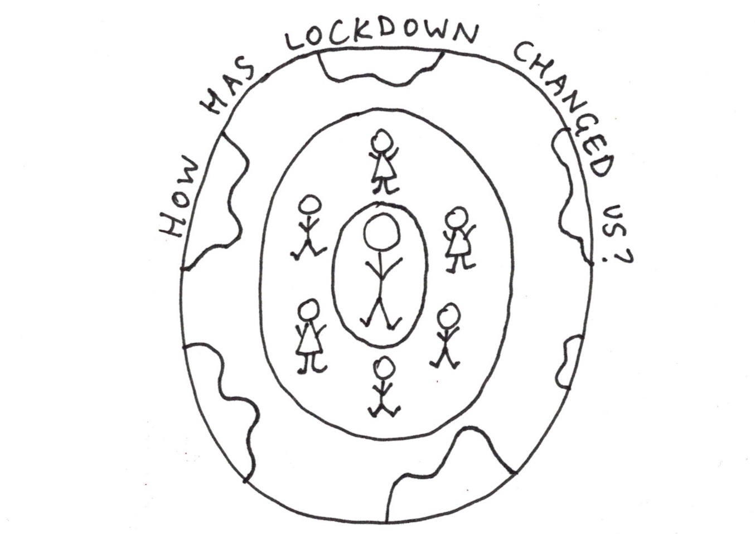

Thank You for taking part.

We all care about loneliness. For some people being socially isolated, staying home and not being able to join in is the norm even without lockdown. The majority of us now know how that feels, and we have a choice. We can rush back to how life used to be as soon as we are allowed, or we can choose to do things a bit differently.
Grapevine are actively looking for people who want to do things differently to be part of a movement against loneliness and isolation.
We are really grateful to all the Big Lunch Leaders who have gathered people together to talk about what we have seen or experienced in lockdown that is worth keeping - and what we might want to change for the better.
This pack has some activities to support the “ Building on the Best of Lockdown” lunches and a bit more information about Grapevine and how you can get involved.
We hope you enjoy the lunch – and we hope to meet you soon.
Jen

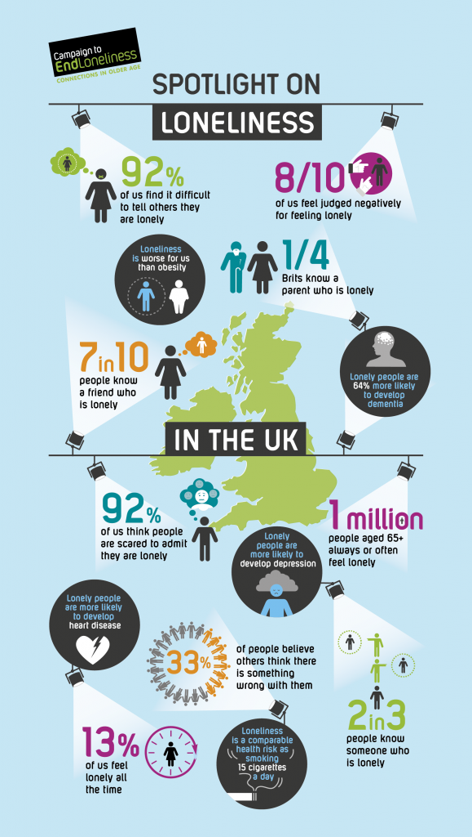

The Lockdown Lowdown
A game

Why not gather your family and play a round of Lockdown Lowdown. You might find out things about each other (and yourself) you never knew!
Take it in turns to roll a dice – move that number and answer the question
No dice? No worries there is a template to make your own on the next page

Start | Favourite relative | Something you are proud of | Something that’s brought you joy in lockdown | Someone you admire
 |  |  |  | Favourite food to eat with friends
Favourite season | What you would do more of if you could | What you would change if you had a magic wand | Something that makes you happy | Something you enjoy that you haven’t done for a while
Anything different you’ve noticed in your community during lockdown

Something you would like to be good at | Favourite relative | Something you enjoy that you haven’t done for a while | What you would change if you had a magic wand | Something that’s brought you joy in lockdown
 |  |  |  | Favourite food to eat with friends
Finish! | Something that makes you happy | Anything different you’ve noticed in your community during lockdown | Someone you admire | Something you are proud of

Make your own dice

Word to the wise. Don’t make the same mistake as I did and snip off the tabs when you are cutting it out!

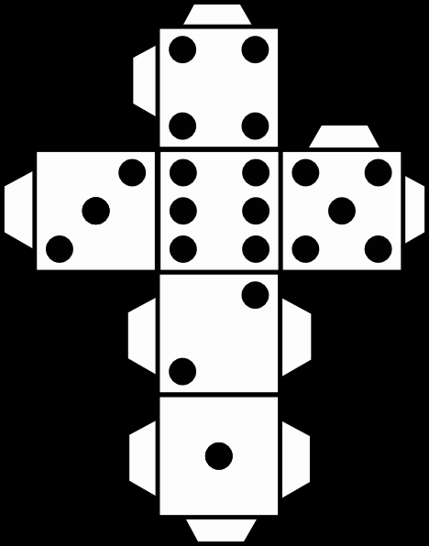

Head, Heart, Bin, Bag*

A different way of reflceting on this strange time we find ourselves in.
Spend a few minutes drawing or writing in each box below. This is just for you, no one will see it or judge it.

Head – anything that you are thinking about at the moment. | Heart – Anything you are feeling
Bin - thoughts, feelings, behaviours, stuff. Anything you wish could be gone. | Bag - everything that is important to you that you want to keep close going forward in your life.

*Thanks to Lindsey for sharing this activity with us. www.lindsayjanehunter.co.uk

The Suitcase*

With restrictions starting to lift now is a good time to reflect on our time in lockdown.
Are there things you used to do that you HAVEN’T missed since lockdown?
Are there things you used to do that don’t seem as important now?
Have you rediscovered something that you used to do?
Have you started new activities that you would like to carry on after lockdown ends?
Are there things you’ve done in lockdown that you haven’t enjoyed and don’t want to carry on with when restrictions lift?

Make notes or draw pictures on the suitcase below. Put what you are taking with you into life after lockdown on the inside of the suitace, and anything you would like to leave behind on the outside.

*Thanks to Creating Space for sharing this activity with us. creatingspace19@gmail.com

The Pledge

We can ALL do something to reduce loneliness for ourselves and for others.
Grapevine want to bring people together who are prepared to take action to make the future a more positive, connected place where loneliness is felt less often and by less people.
Please use the space below to doodle a little self portrait and write what pledge(s) you would like to make that Build on the Best of Lockdown.
We would love a photo of you holding up your pledge – you can upload to facebook with #connectingforgood or email it to me at the address below.

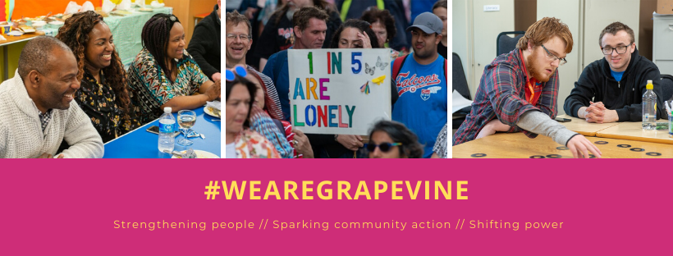

- At Grapevine we love nothing more than a natter over a drink so why not meet us for a virtual cuppa where we can get to know each other better.

- Check us out on Facebook, Insta or Twitter or take a look at our website https://www.grapevinecovandwarks.org/about-grapevine/what-we-do/

- We have a film screening and discussion coming up on Monday June 15th which explores loneliness – what it is and where it comes from. We would love you to join us on Zoom for it.

- Also coming soon – our Connecting for Good Summit – a gathering of people committed to taking action against loneliness.

- We have been training up movement makers in our Change Maker University. We are looking for people who would like to join our next group starting in Summer. Could it be you?????
